Sweet tooth locations

Capstone Report

Jonathan O

Introduction

Sweet tooth is a fake bakery that is trying to gain insight on where they can build there 5 locations, one in each borough of Manhattan. When placing a new branch of any company, the location plays a big part. Picking around other popular bakery locations will negatively affect a branches notoriety which can affect profits. Picking to far from any notable locations can also affect notoriety since it would be hard for people to get to the location. Sweet tooth also wants to cater to the vamped tourist population of New York and take this into consideration when planting a location. This paper discusses the data collection, the methodology used to analysis the data, the results, and a discussion of what was found.

Data Source

The data we will was found though Foursquares API. I used this to find the point of interest in each borough. We also need the API to find competitors in the area. We will be checking nearest bakeries in a 5-mile radius of the point of interest.

Methodology

We will need a fair number of libraries in order to do this study. We will need the requests, random, pandas and NumPy libraries. We would also need to install the geopy client which would help generate coordinates of cities, countries, and landmarks. Next, we would need to import Image and HTML from IPython.display. Next json_normalize imported from pandas.io.json for reading json files as a data frame and lastly, we import the folium library for plotting.

Results

These are the results of the code. Each result has a picture of a map that has nearby bakeries. The red circle represents the radius of reasonable distance with the center being the tourist attraction. The blue circles are representation of the nearest bakeries. This will show relative competition which can help lead to a decision of picking a branch location.

Map for Queens

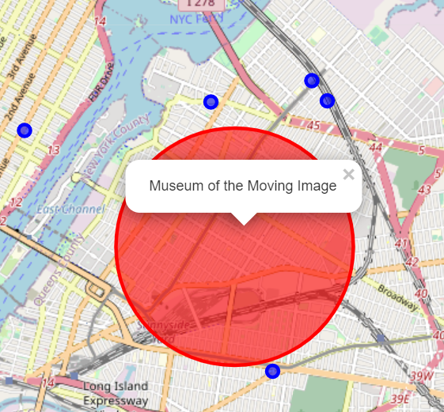

Map of Staten Island

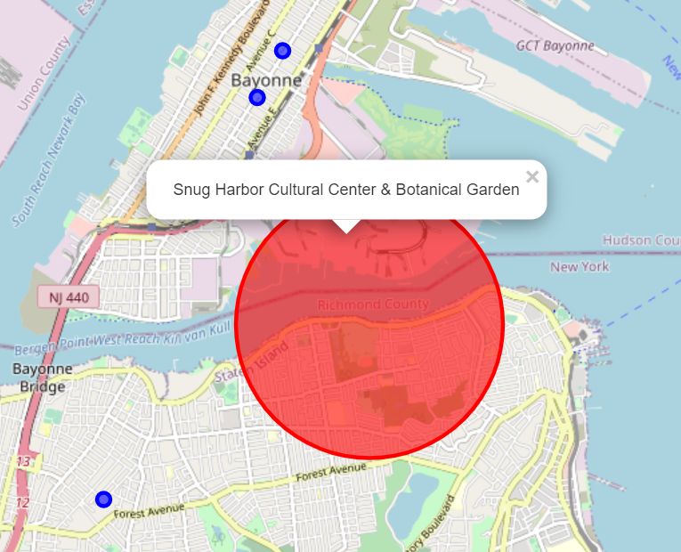

Map of Brooklyn

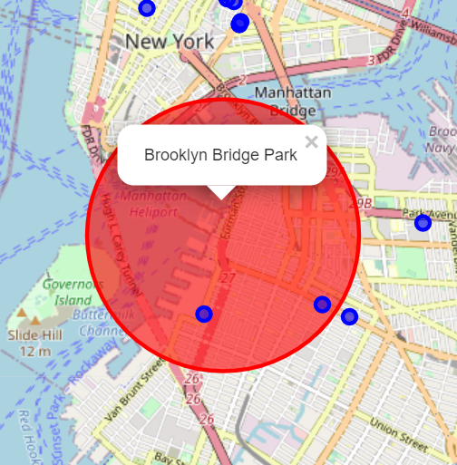

Map of Bronx

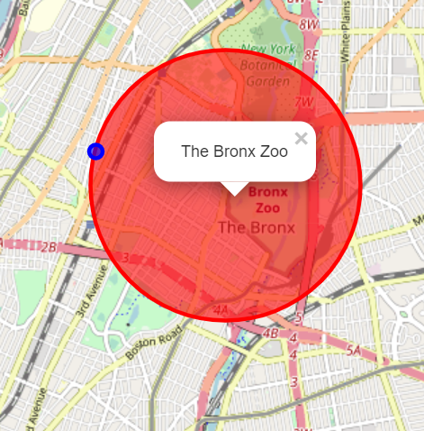

Map of Manhattan

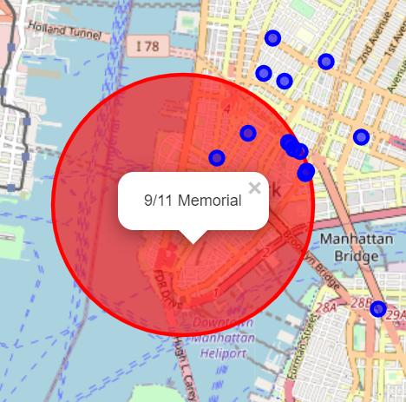

Discussion

From these results we can see that the locations that are selected work well in queens, Staten island and the Bronx. The location selected in Brooklyn had more competition but most of the competition had low ratings so it can still plant a branch and succeed. The branch that is supposed to be planted in Manhattan has a lot of competition so it maybe best to pick another location to open a branch in this borough.